4 WEEKS TO A STRONGER YOU!

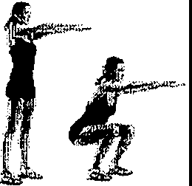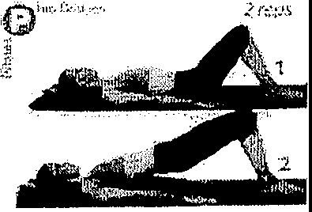

Dead bug Superman
Wall Angels Squat
Hip Bridge Side Plank

DAY 1: 4 reps of each | DAY 11: 8 reps of each, repeat 3x | DAY 21: 11 reps of each, repeat 4x
Wedge: 3 min | Wedge: 10 min | Wedge: 15-20 min
DAY 2: 6 reps of each | DAY 12: Rest | DAY 22: 12 reps of each, repeat 4x
Wedge: 4 min | Wedge: 11 min | Wedge: 15-20 Min
DAY 3 8 reps of each | DAY 13: 9 reps of each, repeat 3x | DAY 23: 13 reps of each, repeat 4x
Wedge: 5 min | Wedge: 12 min | Wedge: 15-20 min
DAY 4: Rest | DAY 14: 10 reps of each, repeat 3x | DAY 24: Rest
Wedge: 6 min | Wedge: 13 min | Wedge: 15-20 min
DAY 5 4 reps of each, repeat 2x | DAY 15: 11 reps of each, repeat 3x | DAY 25: 8 reps of each, repeat 5x
Wedge: 7 min | Wedge: 14 min | Wedge: 15-20 min
DAY 6: 6 reps of each, repeat 2x | DAY 16: Rest | DAY 26: 9 reps of each, repeat 5x
Wedge: 8 min | Wedge: 15 min | Wedge: 15-20 min
DAY 7: 8 reps of each, repeat 2x | DAY 17: 8 reps of each, repeat 4x | DAY 27: 10 reps of each, repeat 5x
Wedge: 9 min | Wedge: 15-20 min | Wedge: 15-20
DAY 8: Rest | DAY 18: 9 reps of each, repeat 4x | DAY 28: Rest
Wedge: 10 min | Wedge: 15-20 min | Wedge: 15-20
DAY 9: 10 reps of each, repeat 2x | DAY 19: 10 reps of each, repeat 4x | DAY 29: 11 reps of each, repeat 5x
Wedge: 10 min | Wedge: 15-20 min | Wedge: 15-20
DAY 10: 12 reps of each, repeat 2x | DAY 20: Rest | DAY 30: 12 reps of each, repeat Sx
Wedge: 10 min | Wedge: 15-20 | Wedge: 15-20

